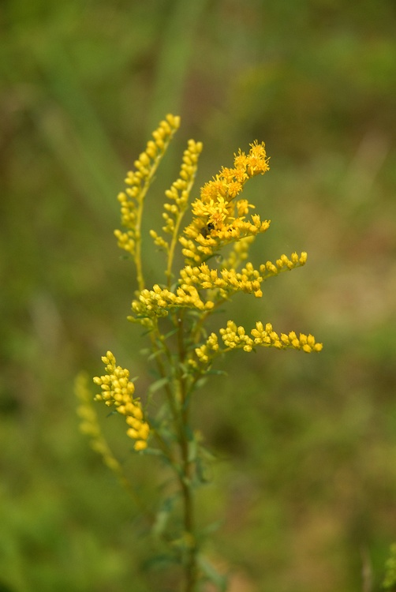

Connemara Conservancy

Welcomes you to the Meadow on

November 8th from
8:00 a.m. to 5:00 p.m.

To enjoy the seasonal changes happening in the Connemara Conservancy Meadow.

Join us for:

8 a.m. Bird Walk
11 a.m. Photography Walk
2 p.m. Family Nature Club

*There will be hands-on activities for children
from 1p.m. to 2 p.m. preceding the FNC walk.

Or Just Come Visit
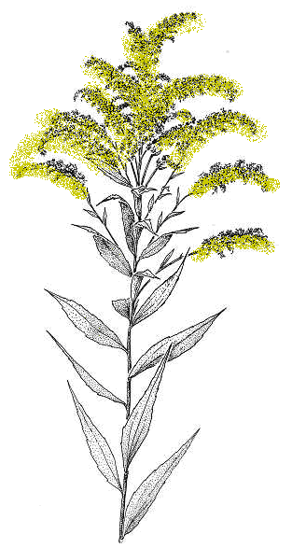
Please RSVP for the planned activities:
rsvp@connemaraconservancy.org

Questions – 214-351-0990
www.connemaraconservancy.org

