An Evening with RICHARD LOUV
Author of the national best seller “Last Child in the Woods”
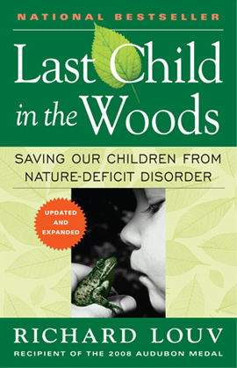

Richard Louv, author and recipient of the 2008 Audubon Medal, identified a phenomenon we all knew existed but couldn't quite articulate: nature-deficit disorder. Since its initial publication, his book Last Child in the Woods has created a national conversation about the disconnection between children and nature, and his message has galvanized an international movement.

Join us at the Dallas Arboretum on Thursday, November 5 at 7pm for a special evening with Mr. Louv. He will share his passion for reconnecting children with nature and answer questions about how we can help Dallas’s children have a brighter future by creating happier, healthier and smarter kids! A book signing will follow the lecture.

Connemara Conservancy has received special group pricing. If you are interested in attending please contact Jennifer at jennifer@connemaraconservancy.org or 214-351-0990.

